Name

Mathematics Stage 5 Paths
Volume of Pyramids, Cones, Spheres

Book 1 |  | Version: 261002  Feedback:  https://MrDingMaths.com
Contents
Syllabus Content 2
Learning Intention 3

Syllabus Content
MA5-VOL-P-01 applies knowledge of the volume of right pyramids, cones and spheres to solve problems involving related composite solids
Solve problems involving volumes
- Find the volume of right pyramids and right cones by using an appropriate formula: volume of pyramid or cone $V=\frac{1}{3}Ah$, where $A$ is the base area and ℎ is the perpendicular height
- Find the volume of spheres by using an appropriate formula: volume of sphere $V=\frac{4}{3}πr^{3}$, where $r$ is the length of the radius
- Apply knowledge of right pyramids, right cones and hemispheres to solve problems involving composite solids
- Solve practical problems related to the volumes and capacities of solids including right pyramids, right cones and spheres

Volume of Pyramids and Cones Part 1

- Volume of Pyramids and Cones
- A pyramid is a 3D solid with a flat base and triangular sides that meet at a point called the apex.
- The perpendicular height is the vertical distance from apex to base.
- A cone is like a pyramid, but with a circular base.
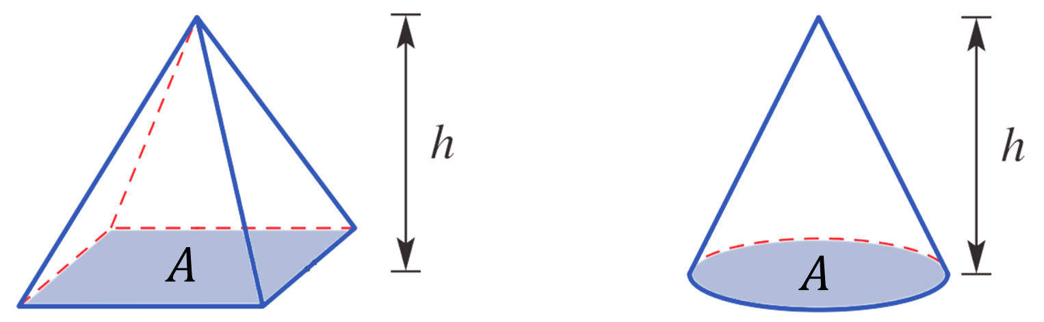

$V=$ $\frac{1}{3}$ $Ah$ or $V=$ $\frac{Ah}{3}$

- Example Calculate volumes of pyramids and cones
Calculate the volumes to the nearest m³.
$$V=\frac{1}{3}Ah \\ =\frac{1}{3}×(5×5)×6$$  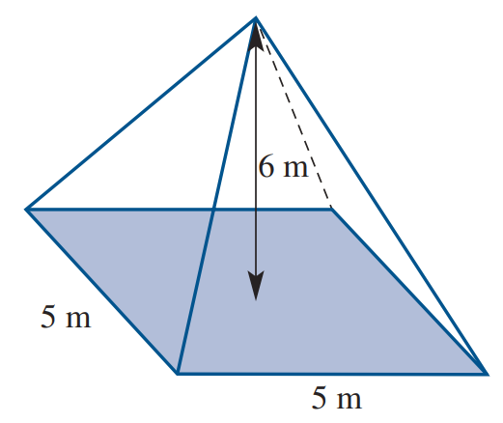  $=50 m^{3}$ | $$V=\frac{1}{3}Ah \\ =\frac{1}{3}×π{\left(5\right)}^{2}×12$$  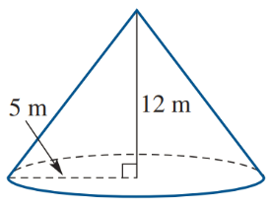  $≈314 m^{3}$

- Guided Practice
Calculate the volumes of these pyramids and cones. Round your answer to 2 d.p.
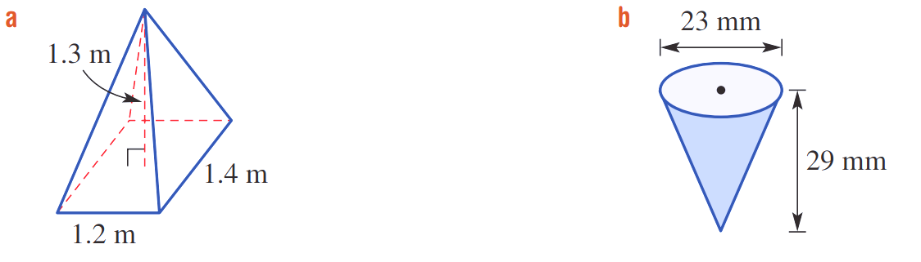  $$V=\frac{1}{3}Ah$$  $=$  $=$  0.73 m³ | $$V=\frac{1}{3}Ah$$  $=$  $=$  4016.26 mm³

- Key Ideas
- The volume of a pyramid or a cone is one third times the …………… …………… and the height.
- The height of a pyramid or a cone is the ………………… distance between the apex and the base.

Foundation
- Find the volume of these solids with the given base areas.
Round your answer to 2 decimal places.
$$V=\frac{1}{3}Ah$$  $=$  10 m³ | 2.67 cm³ | 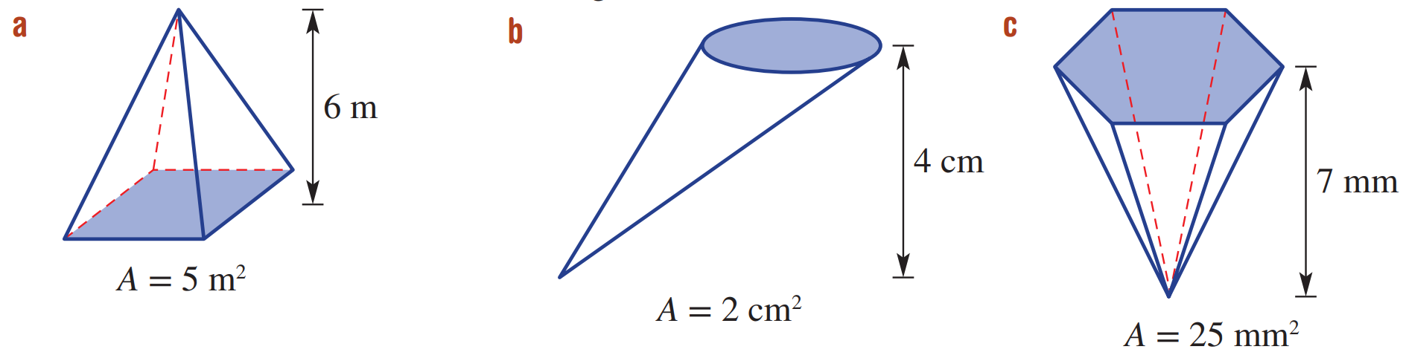  58.33 mm³

- Find the volume of these solids. Round your answer to 2 decimal places.
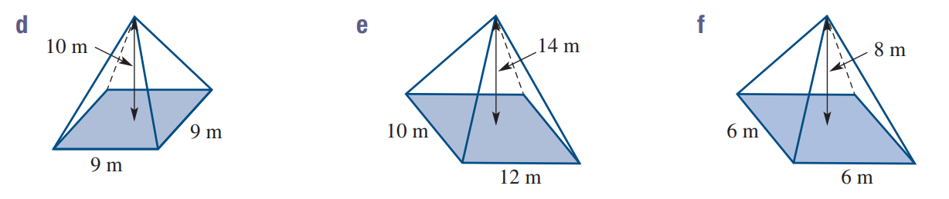  $$V=\frac{1}{3}Ah$$  $=$  270 m³ | 560 m³ | 96 m³
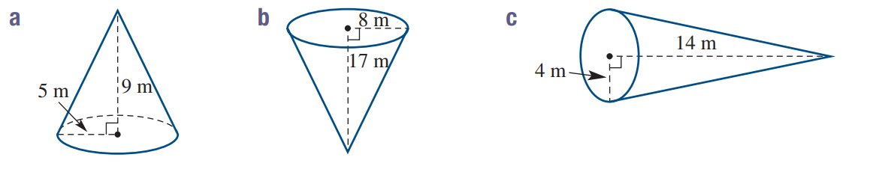  235.62 m³ | 1139.35 m³ | 234.57 m³

Development
- Find the volumes of these pyramids.
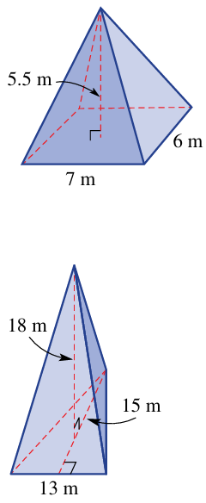  77 m³ | 585 m³

- Find the volumes of these cones, round your answer to 2 decimal places.
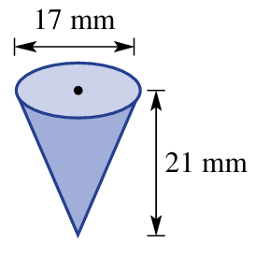  1588.86 mm³ | 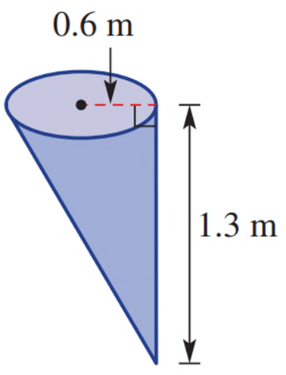  0.49 m³ | 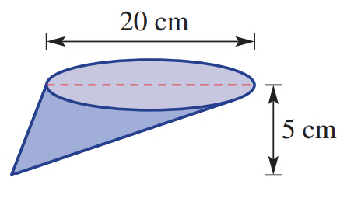  523.60 m³

- The Red Pyramid in Egypt is the third tallest pyramid ever built.
It has a square base with a side length of 220 m and a perpendicular height of 104 m.
  - What is the area of the square base? ………………………………………………………
  - Determine the volume of the Red Pyramid. Answer to the nearest cubic metre.

1 677 867 m³
- An ice-cream cone measures 4.6 cm in diameter and is 9 cm high.
Calculate the volume of the cone. Answer correct to two decimal places.

49.86 m³

Mastery
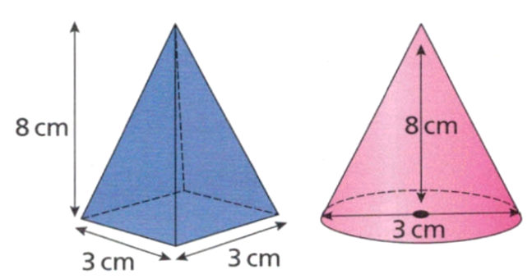
- What is the difference between the volumes of these two solids?

5.15 cm³
- 2018 HSC Standard 2 Band 4
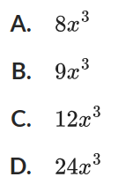
What is the volume of the pyramid in cubic metres?
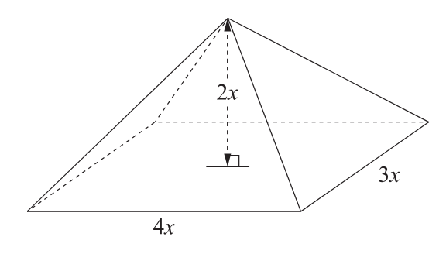

A

Volume of Pyramids and Cones Part 2

- Volume of Pyramids and Cones
- For some questions, you will need to find the perpendicular height before applying the formula.
- Find perpendicular height using Pythagoras: $a=\sqrt{c^{2}-b^{2}}$
Do not round your answer.
- Calculate volume using $V=$ $\frac{Ah}{3}$.

- Example Calculate volumes of pyramids & cones by finding perp height
Calculate the volumes of these pyramids and cones to one decimal place.
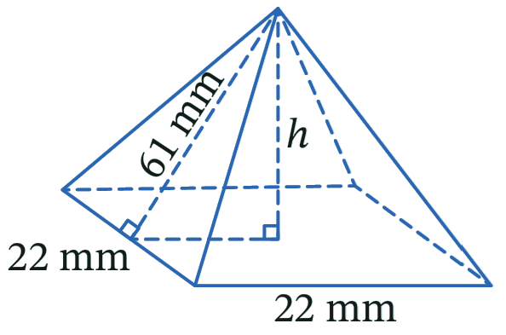  1.  $$h=\sqrt{{61}^{2}-{11}^{2}}$$  $=60$  2.  $$V=\frac{1}{3}Ah$$  $$=\frac{1}{3}\left(22×22\right)\left(60\right)$$  $=9680$ mm³ | 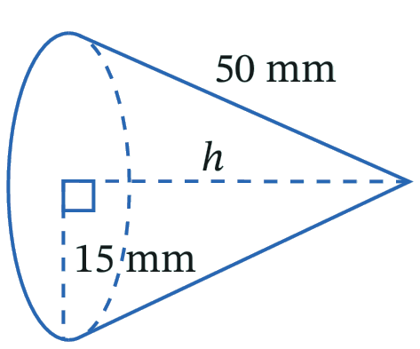  1.  $$h=\sqrt{{50}^{2}-{15}^{2}}$$  $=\sqrt{2275}$  2.  $$V=\frac{1}{3}Ah$$  $$=\frac{1}{3}\left(π×{15}^{2}\right)×\sqrt{2275}$$  $=11238.3$ mm³

- Guided Practice
Calculate the volumes of these pyramids and cones. Answer to the nearest whole.
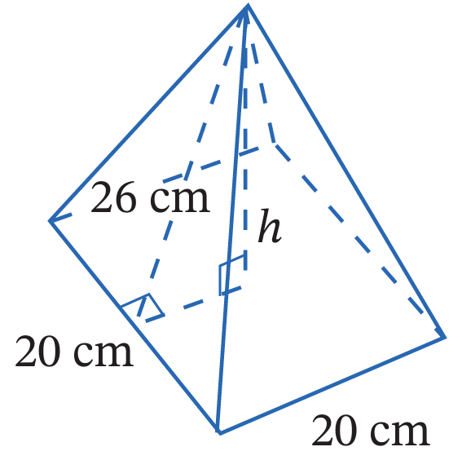  1.  2.  3200 cm³ | 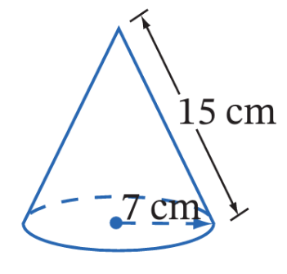  681 cm³

Development
- Find the volume of these pyramids and cones. Answer to 1 d.p.
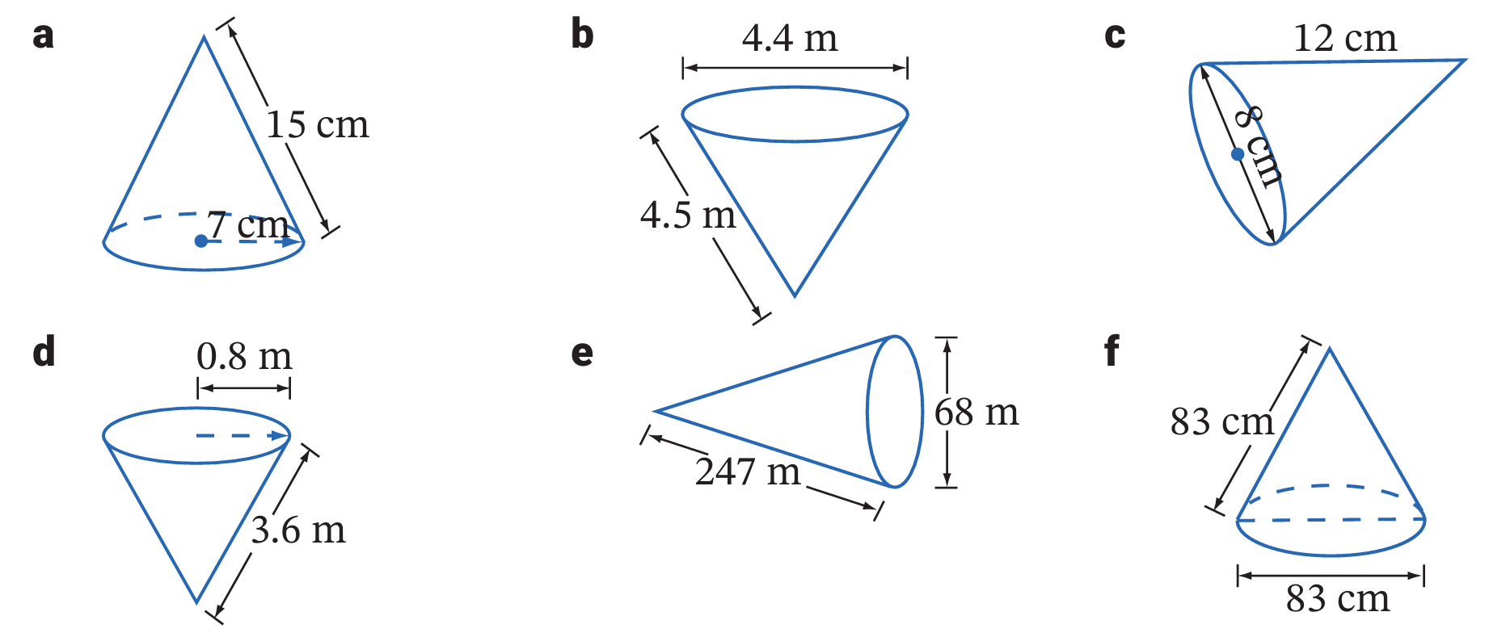  2.4 m³ | 19.9 cm³ | 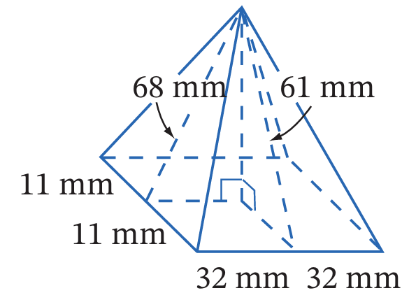  28 160 mm³
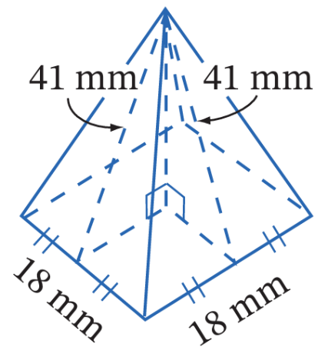  4320 mm³ | 189.6 cm³ | 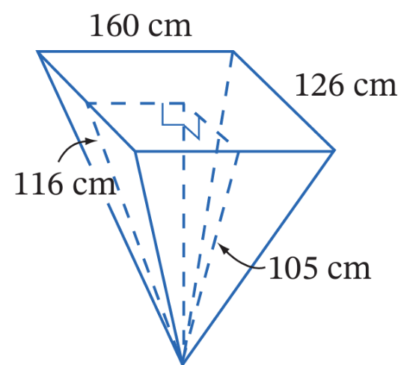  564 480 mm³

Mastery
- Find the volume of this square pyramid. Answer to 1 d.p.
(Hint: you are given the edge height; to make a right-angled triangle you need to use the diagonal of the base.)
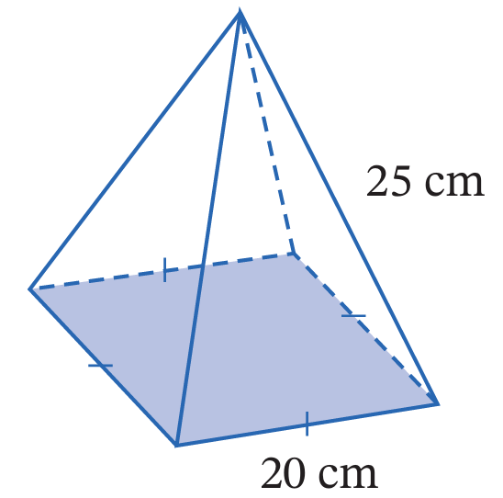

2748.7 cm³
- A triangular pyramid has a base with sides 16 m, 17 m and 17 m.
The height of the pyramid is 20 m. What is the volume of the triangular pyramid?
(Hint: you need to use Pythagoras’ Theorem to find the height of the base triangle)
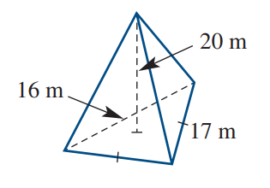

800 m³

Volume of Spheres and Hemispheres

- Volume of Spheres and Hemispheres
- A sphere is a perfectly round 3D solid.
- A hemisphere is half a sphere.
Sphere | Hemisphere
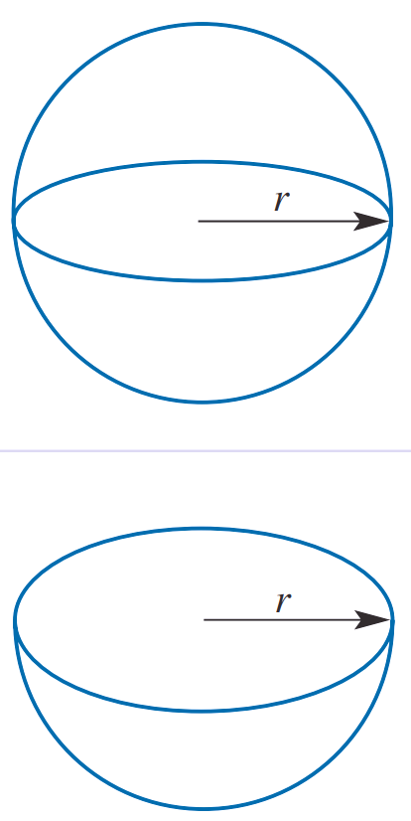  $$V=\frac{4}{3}πr^{3}$$ | $$V=\frac{1}{2}×\frac{4}{3}πr^{3}$$

- Example Calculate volumes of spheres and hemispheres
Calculate the volumes of these spheres and hemispheres to one decimal place.
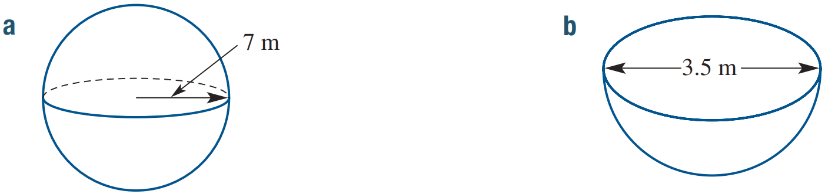  $$V=\frac{4}{3}πr^{3} \\ =\frac{4}{3}×π×7^{3}$$  $≈1436.8 m^{3}$ | $$V=\frac{1}{2}×\frac{4}{3}πr^{3} \\ =\frac{1}{2}×\frac{4}{3}×π×{1.75}^{3}$$  $≈11.2 m^{3}$

- Guided Practice
Calculate the volumes of these spheres and hemispheres. Answer to 1 d.p.
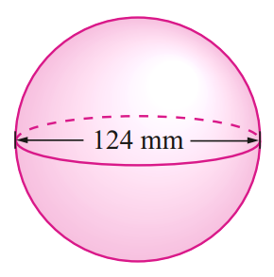  $$V=\frac{4}{3}πr^{3}$$  $=$  $=$  998 306.0 mm³ | 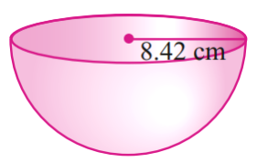  $$V=\frac{1}{2}×\frac{4}{3}πr^{3}$$  $=$  $=$  1250.2 cm³

Foundation
- Calculate the volume of these spheres. Round your answer to 1 decimal place.
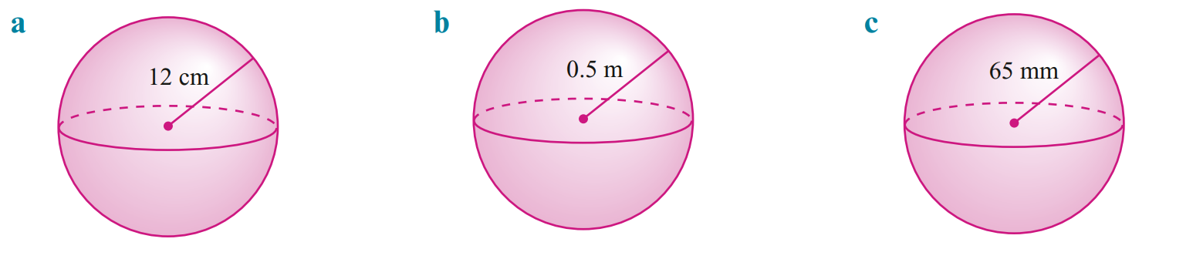  $$V=\frac{4}{3}πr^{3}$$  $=$  $=$  7238.2 cm³ | 0.5 m³ | 1 150 346.5 mm³

- Calculate the volume of these spheres. Round your answer to 1 decimal place.
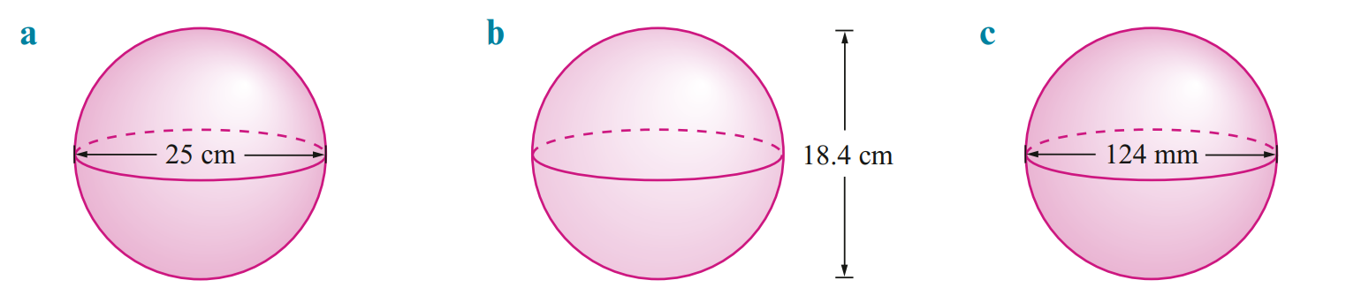  $$V=\frac{4}{3}πr^{3}$$  $=$  $=$  8181.2 cm³ | 3261.8 cm³ | 998 306.0 mm³

- Calculate the volume of these spheres. Round your answer to 1 decimal place.
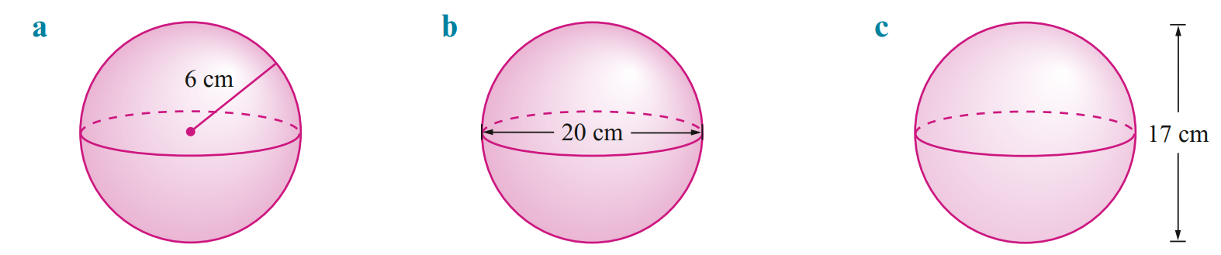  904.8 cm³ | 4188.8 cm³ | 2572.4 cm³

Development
- Calculate the volume of these hemispheres. Round your answer to 2 decimal places.
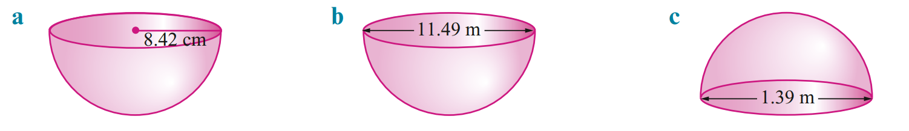  $$V=\frac{1}{2}×\frac{4}{3}πr^{3}$$  $=$  $=$  1250.24 cm³ | 397.13 m³ | 0.70 m³

- Find the radius of these spheres with the given volumes, correct to 2 decimal places.
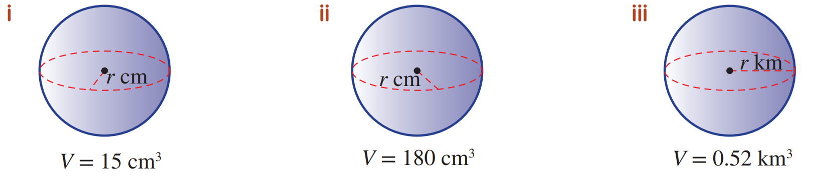  1.53 cm | 3.50 cm | 0.50 km

- Work out the volume of each shape to 1 d.p.
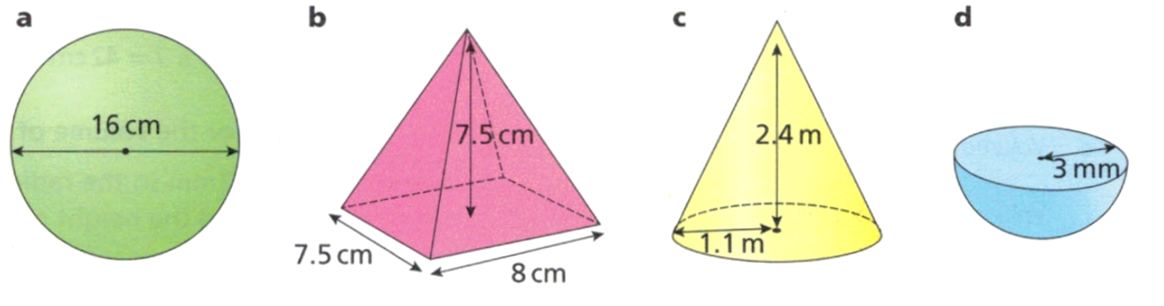  2144.7 cm³ | 150.0 cm³ | 3.0 m³ | 56.5 mm³
- Water drops falling from a tap are spheres of diameter 0.4 cm.
15 drops per minute leak from the tap.
How much water, to the nearest mL, is wasted in one day? (1 mL = 1 cm³)

724 mL
- A ball’s radius is doubled. How many times as large is the new ball?

8 times as larger
- A box 30 cm long, 30 cm wide and 30 cm high holds 50 tennis balls of radius 3 cm. Find:
  - the volume of one tennis ball, correct to 3 decimal places.

113.097 cm³
  - the volume of 50 tennis balls, correct to 1 decimal place.

5654.9 cm³
  - the volume of the box not taken up by the tennis balls, correct to 1 decimal place.

21345.1 cm³
- 2019 HSC Standard 2 Band 4
A bowl is in the shape of a hemisphere with a diameter of 16 cm.
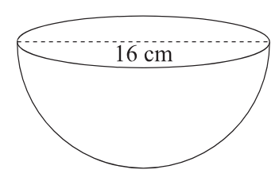
What is the volume of the bowl, correct to the nearest cubic centimetre?

1072 cm³

Mastery
- Work out the value of $x$ in each of these shapes.
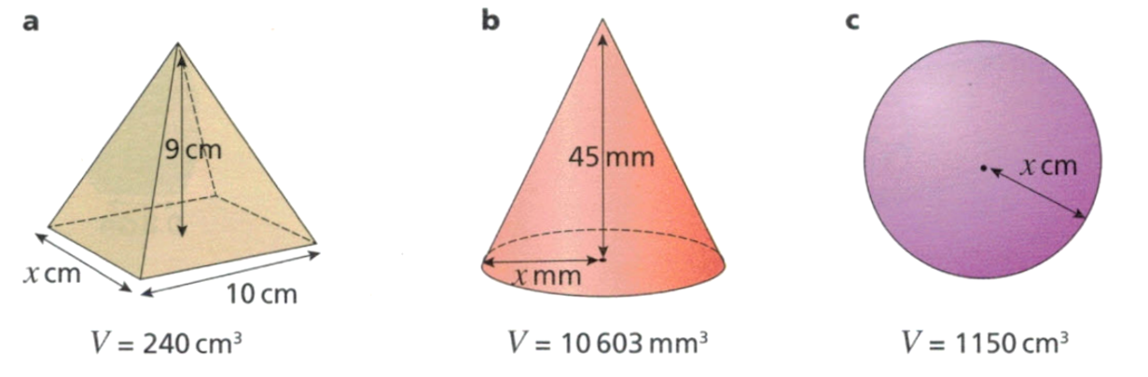  8 | 15 | 6.5

- An expanding spherical storage bag has 800 cm³ of water pumped into it.
Find the diameter of the bag after all the water has been pumped in. Answer to 2 d.p.

11.52 cm
- When a balloon is blown up it roughly forms a sphere.
By taking a large breath, a teenager can expel 1.2 L of air from their lungs.
How many of these breaths would be needed to make a balloon of diameter of 26 cm?

8 breaths
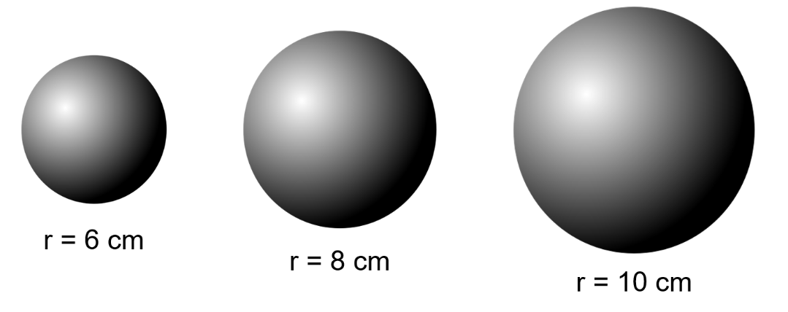
- Three metal spheres are melted down and made into one bigger sphere.
What the radius of the bigger sphere?

12 cm
- Archimedes found that for a cylinder with the same height as its base, a cone and a sphere can fit perfectly inside (if you melted them down).
$$V_{Cylinder}=V_{Cone}+V_{Sphere}$$
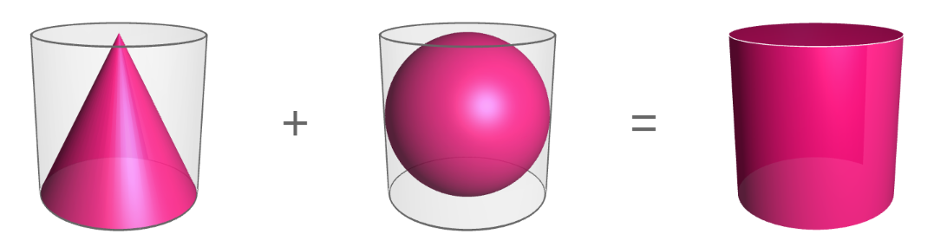

$=$

By substituting the volume of a cylinder $V=πr^{2}h$ and volume of a cone $V=$ $\frac{1}{3}$ $πr^{2}h$,
derive the formula for the volume of a sphere.
(Hint: what is another expression for $h$ in this scenario?)

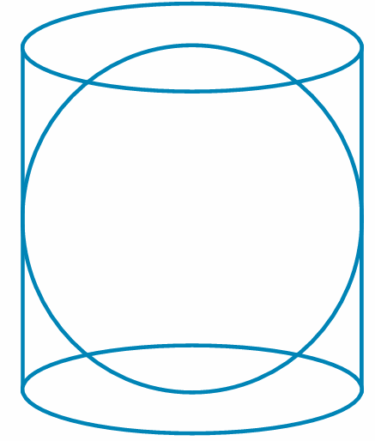
- Archimedes also found that, for a sphere that fits perfectly inside a cylinder:

$$\frac{V_{cylinder}}{V_{sphere}}=\frac{SA_{cylinder}}{SA_{sphere}}$$

Show that this is true.

Volume of Composite Solids

- Volume of Composite Solids
- A composite solid is made up of multiple simple solids.
- To find the volume of composite figures, add or subtract the volumes of simple solids.
- Split the composite solid into simple solids.
- Calculate the volume of each simple solid.
- Add or subtract the volumes.

- Example Calculate the volume of a composite solid
Calculate the volumes of these solids to the nearest two decimal places.
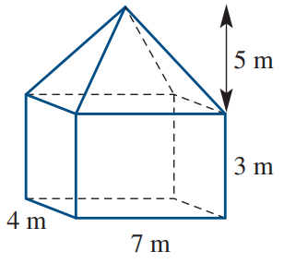  $V_{1}=$ $\frac{1}{3}$ $Ah$  $$=\frac{1}{3}×\left(4×7\right)×5$$  $$=\frac{140}{3}$$  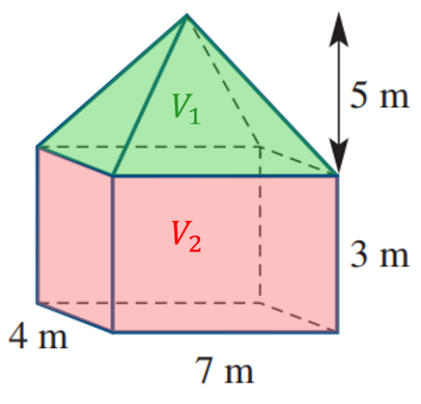  $V_{2}=Ah$  $=(4×7)×3$  $$=84$$  $$V_{tot}=V_{1}+V_{2}$$  $=130.67 m^{3}$ | 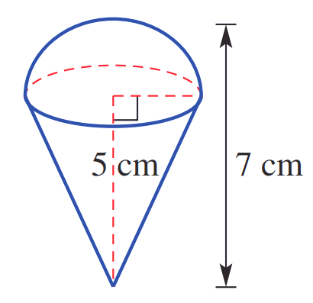  $V_{1}=$ $\frac{1}{2}$ $×$ $\frac{4}{3}$ $πr^{3}$  $$=\frac{1}{2}×\frac{4}{3}×π{\left(2\right)}^{3}$$  $=16.75516082…$  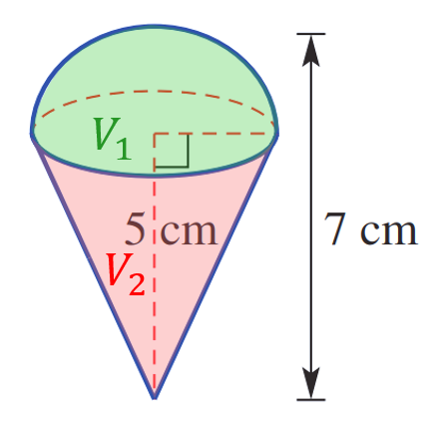  $$V_{2}=\frac{1}{3}Ah$$  $$=\frac{1}{3}×π{\left(2\right)}^{2}×5$$  $=20.94385102…$  $$V_{tot}=V_{1}+V_{2}$$  $=37.70 {cm}^{3}$

- Guided Practice
Calculate the volumes of these solids to the nearest two decimal places
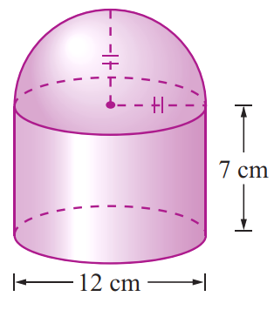  $V_{1}=$  $V_{2}=$  $V_{tot}=$  1244.07 cm³ | 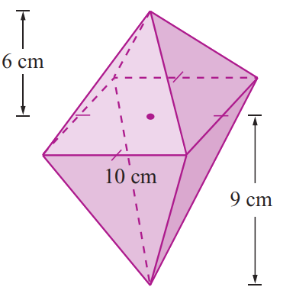  $V_{1}=$  $V_{2}=$  $V_{tot}=$  500 cm³

Foundation
- Calculate the volume of these composite solids. Round your answer to 1 decimal place.
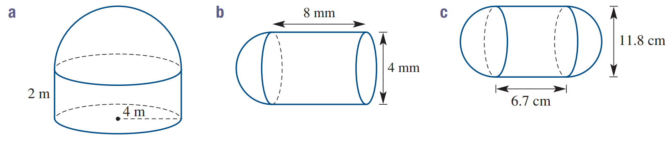  $V_{1}=$  $V_{2}=$  $V_{tot}=$  234.6 m³ | 117.3 mm³ | 1593 cm³
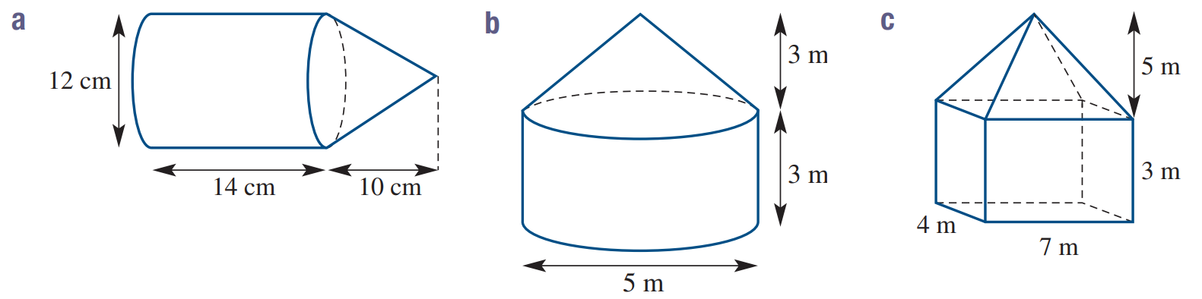  1960.4 cm³ | 78.5 m³ | 130.7 m³
- Calculate the volume of these composite solids. Round your answer to 2 decimal places.
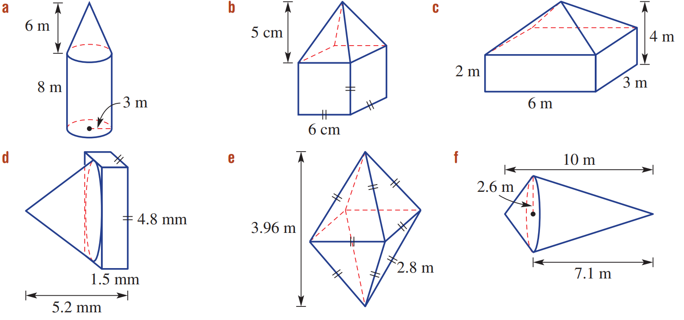  282.74 m³ | 276 cm³ | 48 m³
56.88 mm³ | 10.35 m³ | 70.79 m³

Development
- A frustum is a portion of a solid. The frustum shown opposite is formed from a cone.
  - What is the volume of the missing top cone? Answer correct to the nearest cubic metre.
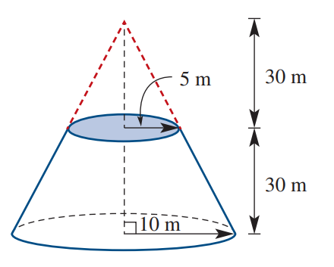

  - What was the volume of the entire cone?

  - What is the volume of the frustum?

5498 m³

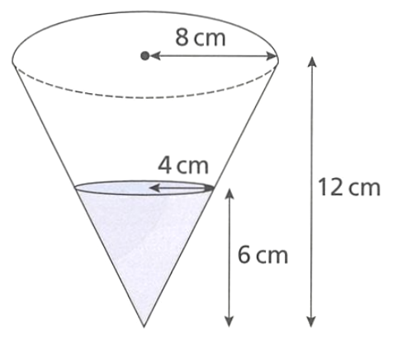
  - Explain why this cone is NOT half full.

  - Work out the fraction of the cone that is filled with water.

$$\frac{1}{8}$$

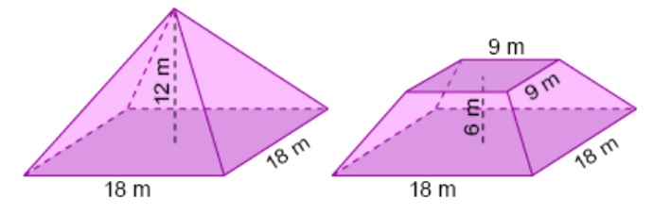
- A frustum is a cone or pyramid with its top cut off.

Volume of complete pyramid:  1296 m³ | Volume of removed pyramid:  162 m³
Volume of frustum:

1134 m³
A formula for a square pyramid frustum was found on a papyrus scroll from $≈$1800 BC:

$$V=\frac{1}{3}h\left(a^{2}+ab+b^{2}\right)$$

where $a$ is the base length, $b$ is the top side length of the truncated pyramid,
and $h$ is the perpendicular height of the truncated pyramid.
Calculate volume using this formula and comment on its accuracy.

very accurate

- A hemispherical scoop of ice-cream is taken out of a cubic tub.
Find the volume that remains, as a percentage.
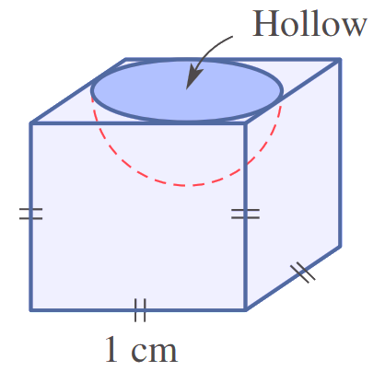

74%
- A cone sits exactly inside a cylinder as shown. The height of the cone is 16 cm.
What fraction of the volume of the cylinder is the cone?
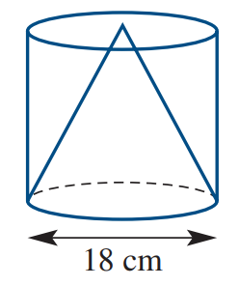

$$\frac{1}{3}$$

Mastery
- 2013 HSC Standard 2 Band 4
A square pyramid fits exactly on top of a cube to form a solid. What is the volume of the solid?
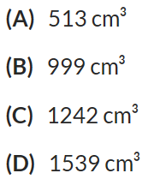
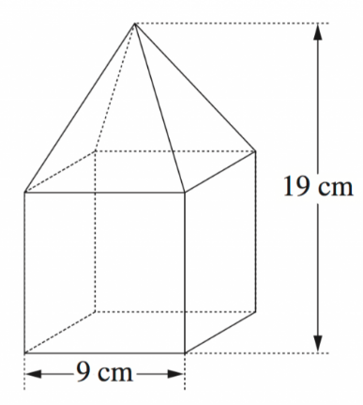

B
- 2009 HSC Standard 2 Band 4
Two identical spheres fit exactly inside a cylindrical container, as shown.
The diameter of each sphere is 12 cm.
What is the volume of the cylindrical container, to the nearest cubic centimetre?
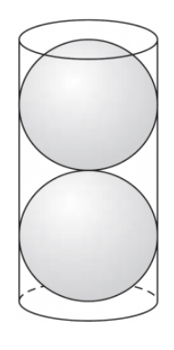

2714 cm³

- A sphere just sits inside a cube. What is the volume of the sphere as a percentage of the volume of the cube? Round your answer to the nearest whole percentage.
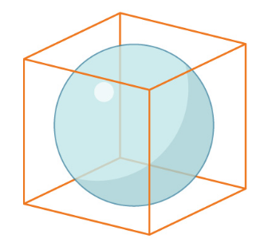

52%
- A ball just fits inside a cylinder. What percentage of the volume of the cylinder is taken up by the ball? Round your answer to the nearest whole percentage.
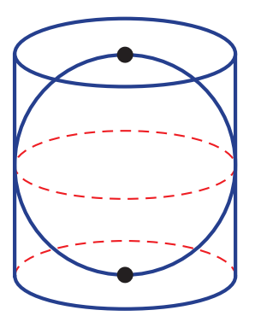

67%
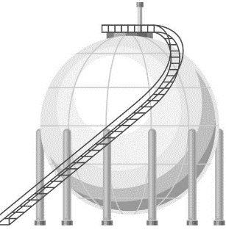
- A spherical container has an outer radius of 8 m and a steel shell that is 40 mm thick.
What is the volume of the shell?

32 m³
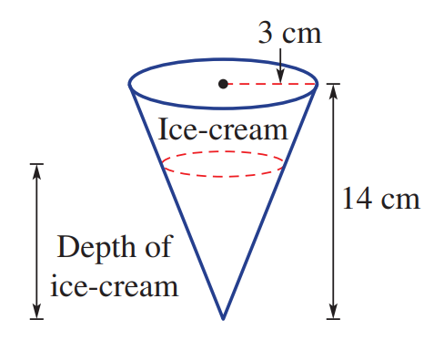
- The volume of ice-cream in the cone is half the volume of the cone.
The cone has a 3 cm radius and height of 14 cm, as shown.
What is the depth of the ice-cream, correct to 2 decimal places?

11.11 cm

